2020-2021
State Pin and Tee Contest*
Open to teams, team member(s), or other participants in KY Odyssey of the Mind.
**************************************************************************************************
Contest Notes: This year’s contestants are asked to create designs for one or two pins and a t-shirt that fit with last year’s (2019-2020) pin. (Pictured below)
We are looking for ideas that creatively add to last year’s pin set in some way. Designs that are in color are much easier to evaluate!
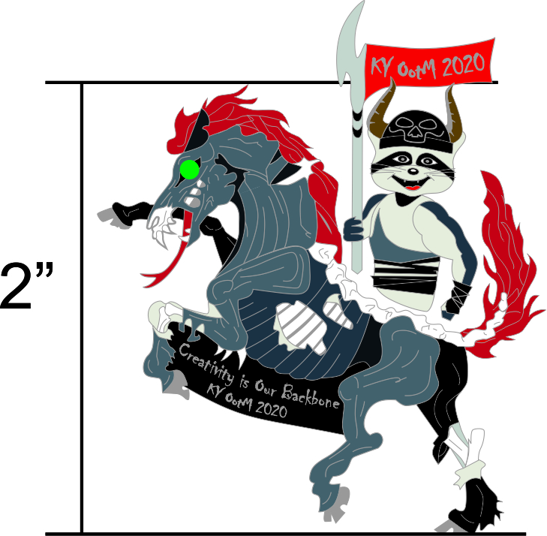

Designs should be on 8 ½” by 11” paper and designs should be on the front only.
Odyssey of the Mind must either be spelled out or you can use OotM.
Do not put names on the front of the designs.
Please put the contestant’s name, the contestant’s school, the contestant’s (complete) home address, and a contact email address on the back of the design.
Designs will not be returned.
Mail Designs To:
Matthew Pippin
1008 Burning Springs Dr.
Shelbyville, Kentucky 40065

Deadline: MUST BE POSTMARKED BY OCT. 31, 2020

*The Board reserves the right to make adjustments to the design.

